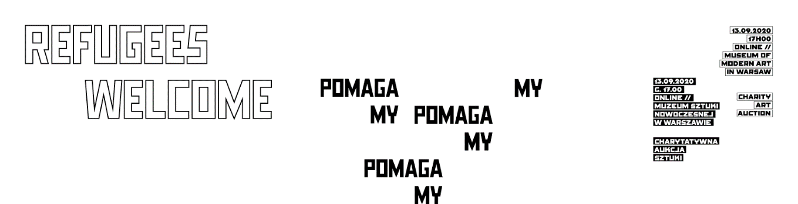

31.08.2020
Press release

A celebration of solidarity

The Refugees Welcome Charity Art Auction will be held on 13 September 2020. The auction catalogue is already available. Honorata Martin, Miriam Cahn, Tadeusz Rolke, Paweł Althamer, Radek Szlaga, Rafał Milach: these are just a few of the names appearing in this year’s Refugees Welcome auction. The proceeds from the auction will go to Ocalenie Foundation to support refugees seeking their place in Poland.
The auction catalogue in Polish and English is now available at RefugeesWelcome.pl.

“This year, despite the unusual situation, we managed to obtain the support of over 50 artists,” said Magda Lipska, a curator at the Museum of Modern Art in Warsaw. “Their works differ in style and technique, aesthetic appeal and social engagement, created by young artists just finishing art school and by mature, well-known artists, from Poland and abroad.” As Lipska points out, for many of us migration has become a condition of modern life. More and more often we can ask, like the artist Krzysztof Wodiczko, “Which where are you from?” and not expect a simple answer.
Kalina Czwarnóg, a member of the management board of Ocalenie Foundation, explained: “We have been assisting refugees and migrants for many years, and organizing the auction for four years. It is a unique way to help, with the great added value of solidarity between artists and buyers and those in need of support. We particularly value this initiative in a time of pandemic, when the situation of everyone, including artists, can be especially difficult.”
During the pandemic, refugees and migrants need help more than ever before. Many of them have been left without funds to live on or support their families living far away. Previously just a handful of people every month drew on the foundation’s food aid, but now this number has grown to over 570.
According to auction coordinator Karolina Szymańska: “2020 has shown us that the status quo is not a given we can always rely on. That’s why we especially encourage bidding in the auction. The prices of works start from as low as PLN 300. Last year we managed in raise PLN 200,000. Each year the auction generates greater interest and the amount of aid increases. We hope that will be the case again during this exceptional pandemic year.”
This year the auction will be held on 13 September at the Museum of Modern Art location at ul. Pańska 3 in Warsaw. Much of the bidding will occur online, due to health precautions. The auction will be preceded by an exhibition, which can be viewed during the week leading up to auction, from 7 to 12 September. On 11 September viewers can watch an online concert by Wojciech Puś via live streaming on the social media of the Museum of Modern Art in Warsaw. The time of the concert and the opening of the exhibition will be posted on the sites of Refugees Welcome Poland and the museum.
The 4th edition of the Refugees Welcome Charity Art Auction has gained the support of 53 Polish and foreign artists. All the income from the auction will be devoted to two programmes of Ocalenie Foundation: Refugees Welcome Poland and the Help Centre for Foreigners. Refugees Welcome Poland brings refugees together with Varsovians willing to offer a room in their home. The Help Centre for Foreigners is a unique place in Warsaw. Its employees, who come from six different countries, help foreigners find employment and accommodation, and offer legal and psychological aid. Every year the centre assists some 2,000 people. Over a thousand take free courses in Polish. During the pandemic the centre is operating remotely. It also offers a website with news on the epidemic situation in nine languages.
The organizers of the auction are Ocalenie Foundation, the Museum of Modern Art in Warsaw, and the Society of Friends of the Museum of Modern Art in Warsaw.

Artists participating in the auction:
Paweł Althamer, Babi Badalov, Basia Bańda, Gosia Białobrzycka/Grzegorz Wełnicki, Bownik, Agnieszka Brzeżańska, Magda Buczek, Dorota Buczkowska, Miriam Cahn, Ewa Ciepielewska, Martyna Czech, Rafał Dominik, Jakub Gliński, Zuzanna Golińska, Zuzanna Hertzberg, Piotr Janas, Magdalena Karpińska, Tomasz Kowalski, Dominika Kowynia, Robert Kuśmirowski, Diana Lelonek, Honorata Martin, Agnieszka Mastalerz, Olga Micińska, Rafał Milach, Monika Misztal, Magdalena Moskwa, Marta Nadolle, Anna Niesterowicz, Dominika Olszowy, Witek Orski, Sławomir Pawszak, Joanna Piotrowska, Igor Pisuk, Natalia Poniatowska, Katarzyna Przezwańska, Wojciech Puś, Karol Radziszewski, Joanna Rajkowska, Tadeusz Rolke, Filipka Rutkowska/Milena Liebe, Daniel Rycharski, Mateusz Sarzyński, Maciej Sieńczyk, Slavs & Tatars, Agata Słowak, Marek Sobczyk, Magdalena Starska, Grzegorz Stefański, Radek Szlaga, Iza Tarasewicz, Artur Żmijewski, Konrad Żukowski, Paweł Żukowski.

Contact:
Karolina Szymańska
Ocalenie Foundation
karolina.szymanska@ocalenie.org.pl
tel. 501 712 453

Józefina Bartyzel
Museum of Modern Art in Warsaw
prasa@artmuseum.pl
tel. 695 492 970

